Poetry of
Things We Love

Poetry Selection

A Boy’s Head (1963)

In it there is a space-ship
and a project
for doing away with piano lessons
And there is
Noah’s ark,
which shall be first.
And there is
an entirely new bird
an entirely new hare
an entirely new bumble-bee.
There is a river
that flows upwards.
There is a multiplication table.
There is anti-matter.
And it just cannot be trimmed.
I believe
that only what cannot be trimmed
is a head.
There is much promise
in the circumstance
that so many people have heads.
Miroslav Holub

In Praise of My Bed
At last I can be with you!
The grinding hours
since I left your side!
The labor of being fully human,
working my opposable thumb,
talking, and walking upright.
Now I have unclasped
unzipped, stepped out of.
Husked, soft, a be-er only,
I do nothing, but point
my bare feet into your
clean smoothness
feel your quiet strength
the whole length of my body.
I close my eyes, hear myself
moan, so grateful to be held this way.
Meredith Holmes

Morning

Why do we bother with the rest of the day,
the swale of the afternoon,
the sudden dip into evening,

then night with his notorious perfumes,
his many-pointed stars?

This is the best—
throwing off the light covers,
feet on the cold floor,
and buzzing around the house on espresso—

maybe a splash of water on the face,
a palmful of vitamins—
but mostly buzzing around the house on espresso,

dictionary and atlas open on the rug,
the typewriter waiting for the key of the head,
a cello on the radio,

and, if necessary, the windows—
trees fifty, a hundred years old
out there,
heavy clouds on the way
and the lawn steaming like a horse
in the early morning.

Billy Collins

Adrian Mitchell, ‘Stufferation’
Lovers lie around in it
Broken glass is found in it
Grass
I like that stuff
Tuna fish get trapped in it
Legs come wrapped in it
Nylon
I like that stuff
Eskimos and tramps chew it
Madame Tussaud gave status to it
Wax
I like that stuff
Elephants get sprayed with it
Scotch is made with it
Water
I like that stuff
Clergy are dumbfounded by it
Bones are surrounded by it
Flesh
I like that stuff
Harps are strung with it
Mattresses are sprung with it
Wires
I like that stuff
Carpenters make cots of it
Undertakers use lots of it
Wood
I like that stuff
Cigarettes are lit by it
Pensioners are happy when they sit by it
Fire
I like that stuff
Dankworth’s alto is made of it, most of it,
Scoobeedo is composed of it
Plastic
I like that stuff
Apemen take it to make them hairier
I ate a ton of it in Bulgaria
Yoghurt
I like that stuff
Man-made fibres and raw materials
Old rolled gold and breakfast cereals
Platinum linoleum
I like that stuff
Skin on my hands
Hair on my head
Toenails on my feet
And linen on my bed
Well I like that stuff
Yes I like that stuff
The earth
Is made of earth
And I like that stuff
Adrian Mitchell

My Favourite Things
Raindrops on roses and whiskers on kittens;
Bright copper kettles and warm woolen mittens;
Brown paper packages tied up with strings;
These are a few of my favorite things.

Cream-colored ponies and crisp apple strudels;
Doorbells and sleigh bells and schnitzel with noodles;
Wild geese that fly with the moon on their wings;
These are a few of my favorite things.

Girls in white dresses with blue satin sashes;
Snowflakes that stay on my nose and eyelashes;
Silver-white winters that melt into springs;
These are a few of my favorite things.

When the dog bites,
When the bee stings,
When I'm feeling sad,
I simply remember my favorite things,
And then I don't feel so bad.

Rogers and Hammerstein

My Favorite things

Faint fuzzy quasars
And matter that's hidden.
Pulsars and blazars
And research I've written.
Brown dwarfs and white dwarfs
And strange cosmic strings.
These are a few of my favorite things.

False-color pictures of nebular places.
Faraway realms having poisonous traces.
Emission-line spectra with flux in their wings.
These are a few of my favorite things.

Galaxies streaming with very large redshifts.
Mountains with domes there, not buried in snow drifts.
Four-wheel vehicles bouncing on springs.
These are a few of my favorite things.

When the frost bites,
When the moon's bright,
When the seeing's bad,
I simply remember my favorite things
And then I don't feel so sad.

Kevin Krisciunas

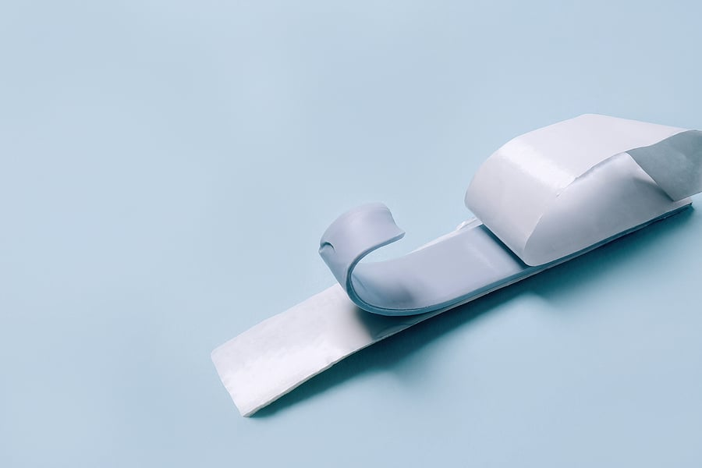

Ode to Blu Tack
Speck of skyslide, Penicillium mold
grown in zero gravity
you have no shape to speak of.
Semi-precious adhesive, you belong with beautiful things.
Ancient Egyptians would have placed you with gold
inlaying death masks with Blu Tack and fingerprints
understanding that a soul takes many forms,
each carrying the same weight.
O Saviour of student rooms!
Of white walls without a place for eyes to fix!
You are true as Coventry blue, unafraid of holding up
the work of others,
your own unrecognised.
Tell me – forbidden snack, crab blood
mixed with cornflour – how can I make change stick
but stay myself?

Jack Cooper

Ode to Marbles
I love the sound of marbles
scattered on the worn wooden floor,
like children running away in a game of hide-and-seek.
I love the sight of white marbles,
blue marbles,
green marbles, black,
new marbles, old marbles,
iridescent marbles,
with glass-ribboned swirls,
dancing round and round.
I love the feel of marbles,
cool, smooth,
rolling freely in my palm,
like smooth-sided stars
that light up the worn world.
Max Mendelsohn

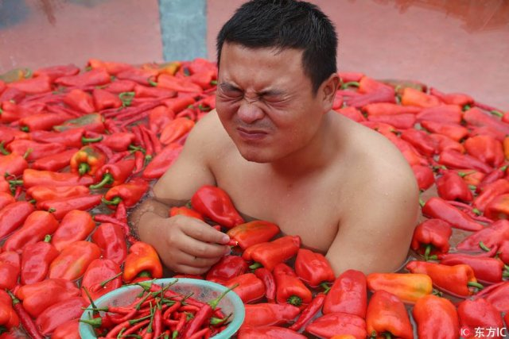

Ode to Food that is “Too Spicy”
You, who birth accidental tears and coughing storms,
plow trails down my throat
and remind me of your existence the next morning
when I think the worst has passed.
You, best cure to a stuffed nose,
exorcism of the weak and untrained: an honor badge.
You, who make white boys
trying to impress their girlfriends at Asian restaurants
admit failure and cry.
Don’t let others tell you the right way to be:
You make me remember human mortality
in the best way possible.
Michelle Yang

Landfall at daybreak
Fetch a saucepan – the small even-handed one with a lip
on either side,
find the flat wooden stirrer, or better still, use the spurtle
Granddad made,
take the rolled oats from the cupboard – the nearest
stout paper packet –
marvel at the pale yellow elephant on the front, outlined
in bright blue,
look for a cup to match the everyday bowls – Willow Pattern,
Woolworth’s best,
fill to the brim with whisper of harvest sprung from earth,
rain and sunlight,
pour into the pan, listen as the soft scurried patter settles
to speckled hush,
add water, use a double measure – plus a dash more – watch
clarity turn to cloud,
place on the burner, stir, feel like the silken swirl begin to chafe
at bubble-burst,
turn the flame right down, cook until resist-of-thicken clings –
this is porridge –
pour into your bowl, mine, deep trails undo, moraines merge
flat and firm,
sprinkle a little brown sugar on top, add just a splash of milk,
a sea of white
floods an island that floats – now, here’s a spoon, sit and eat,
begin at the shore.
Helen Overell

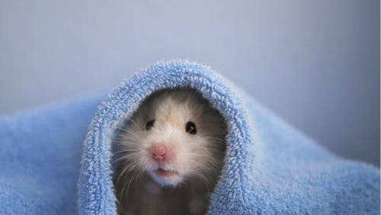
Tammy
For Tammy the hamster
I think perhaps nature made you
Soft for us, because there’s no sane
Reason for you to wear a cloud for a coat.
If there is in your littlenesses
Some ancient, statue-high message
I think it is not a lofty one.
You speak more in the warm
Thereness you bring on my shoulder.
You are but a small piece of animal,
Complete with all deep, rhythmic
Workings of life scaled down to fit
In a furry pocket. Somewhere in all
That honed clockwork, there’s a part
For character, for the way you stand
And stare, posed upright for the cameras
Of our gazes, and squawk over the news.
You are always warmth and weight and wool
And a face like undisturbed waters.
And your eyes are so big, as though
Life has nothing you wish to miss.
Elsie Hayward

Lauren
You’re a new daisy
that’s come up at night,
your skin is
a silk cover rubbed
against my hand.

You’re a moon
drifting through frozen air,
the lady who helps me
when I’m hurt. You are
cream just whipped.

You’re a red lipped flower,
the bit of butter
melting on my potato,
you’re the hot water in my
bath, rushing around me.

You are god talking
quietly to horses,
a rainbow in the sky.
You’re the moment
I get my sums right.
Barry Turrell


High Flight
Oh! I have slipped the surly bonds of Earth
And danced the skies on laughter-silvered wings;
Sunward I’ve climbed, and joined the tumbling mirth
Of sun-split clouds, – and done a hundred things
You have not dreamed of – wheeled and soared and swung
High in the sunlit silence. Hov’ring there,
I’ve chased the shouting wind along, and flung
My eager craft through footless halls of air…

Up, up the long, delirious burning blue
I’ve topped the wind-swept heights with easy grace
Where never lark, or ever eagle flew –
And, while with silent, lifting mind I’ve trod
The high untrespassed sanctity of space,
Put out my hand, and touched the face of God.
John Gillespie Magee

Sea-Fever
I must go down to the seas again, to the lonely sea and the sky,
And all I ask is a tall ship and a star to steer her by;
And the wheel’s kick and the wind’s song and the white sail’s shaking,
And a grey mist on the sea’s face, and a grey dawn breaking.

I must go down to the seas again, for the call of the running tide
Is a wild call and a clear call that may not be denied;
And all I ask is a windy day with the white clouds flying,
And the flung spray and the blown spume, and the sea-gulls crying.

I must go down to the seas again, to the vagrant gypsy life,
To the gull’s way and the whale’s way where the wind’s like a whetted knife;
And all I ask is a merry yarn from a laughing fellow-rover,
And quiet sleep and a sweet dream when the long trick’s over.
John Masefield

Encomium for the First Truly Epic Poem

This is the best poem you have ever read.
Everybody is saying it. Everyone.
Other poems have tried to be as wonderful,
tried to be honored with the best aesthetics,
struggled to be as tremendous as this
and to get away with things like that—believe me—
but they don’t know how. They’re weak and small;
they whine and fumble and lose all the time,
lose to limericks and haiku, senryu and lays.
But not this poem.
This poem spawns only success, has nothing but victories,
knows nothing of loss or the literature of losing,
can’t keep itself from winning, always, bigly.
There has never been a poem like this one.
Elegies and epithalamiums, idylls and odes,
Sestinas and sonnets and carpe diem canzones—
all have tried and failed to be as terrific as this,
the greatest poem, in the greatest journal,
in the greatest country, in the greatest universe on Earth.
This poem is freedom.
This poem doesn’t hide behind walls: it builds them.
This poem is a leader, a champion of meter,
of measures that beat the best out of everyone.
This poem is faith, the flag, a founding father:
a loaded gun in a good man’s hand.
This poem is the voice of America—the groin
in the bridge to a better tomorrow.
Literature, everywhere, is broken—lies in ruins.
But not this poem. Never.
No one had ever heard of Ozymandias—of might or despair.
But this poem had—and only it has the answers, has a plan.
Only this poem is doing something about the wreckage,
the crumbling rubble that sad, little phonies have left us with.
Only the feet of this poem can stand in the swamp,
Only its passages can get us back on the course.
This poem takes risks (like zeugma) but not you for a fool.
Very fine people know this poem puts them first.
But this poem loves the others too, even critics, even readers.
Some of this poem’s best friends are readers.
This poem is going very well, don’t you think?
It really is amazing. Incredible.
It has all the best words.
It’s already shown you some very important stanzas.
Very important stanzas.
This poem alone knows how welcome you are.
There is just nothing like this poem. Nothing.
And only this epic—really something very special—
can make things better and the better the best.
By simply gazing on such greatness,
you can feel yourself begin
to slide past goodness.
By surveilling and scanning but never quite reading, you
can already feel yourself tired of winning,
can already feel yourselves safer, more similar,
can already feel this poem, like nothing before in history,
through huge epizeuxis and classy anaphora,
making us great again great again great again.
Making us more like this poem.
By M. J. Lewis

Poems for assessment

Gael Turnbull, ‘Thanks’
Thanks, and praise for
the knot in the wood

across the grain
making the carpenter curse

where a branch sprang out
carrying sap to each leaf.

Gael Turnbull

‘Ode to the Onion’
I open the front door and walk headlong into
the oh so heavenly scent
of onions sautéing on the stove.
Of course, growing up we would have said “frying”
but onions speak all languages.
The aroma is the same
and the groundedness is the same.
It is the subfloor
upon which the precious hardwood is laid,
the canvas
on which the masterpiece is painted,
the staff
on which the opera is charted,
the ink
with which the poem is written,
the bass note
in the broth.

Susan Whelehan

‘Ode to a Desk Fan’
You, my favourite soprano,
sizzling egg white,
caged bird with metal tongue,
the moon
reflecting the air of the room back to itself.

I turn you on in the morning
and you don’t stop,
spinning gold from the open window,
festooning my face with the curious fingers of unsure ghosts.
You are a crystal ball.
I can’t unpick all your voices
tempering Classic FM as I study.

When I’m done
you look at me like a mother
slowly wiping her hands on an apron,
stilling,
still.

Ellora Sutton

